Working with Layout in ArcGIS Pro
By Jeff Blossom, Center for Geographic Analysis, April, 2020
A page layout allows you to add map frames and other elements, such as a scale bar, legend, north arrow, title, and more. Deciding early on the dimensions and orientation of a layout facilitates the design process. It influences your decisions on factors such as map frame sizes, map scale, text size, and how other map elements may fit.
ArcGIS Pro has rulers, guides, and a grid to help you arrange map elements on a page. You can also align, nudge (move incrementally), distribute (space evenly), order, rotate, and resize selected elements to place them where you want them.
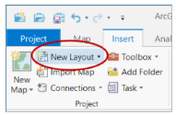
- Create a new layout. To create a Layout, click New Layout on the Insert tab in the Project group:
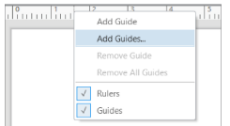
This will prompt you to choose a page size and orientation. Orientation refers to whether the long axis dof the page is horizontal or vertical. If your geographic area extends further East/West than North/South, you might want to set orientation to Landscape. The GIS lab printer can print to both 8.5”x11” (letter) and 11”x17” paper. Once you choose a page size, the Layout will be added as a View to your project. Like maps and data, layouts are stored in the project. You can access a layout at any time from the Project pane in the Layouts folder. Like maps, a contextual tab named Layout appears on the ribbon and contains layout-specific tools. The other tabs also contain contextual layout-specific settings.
- Add guides to your layout.
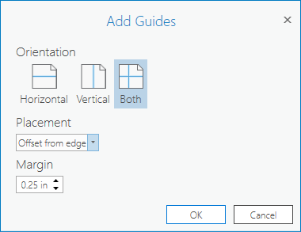
Guides are available to help you position map frames and other elements in your layout. A useful feature is to snap layout elements to guides. When you move or resize any layout element near a guide, the element will snap to the guide. Guides can help frame your content within a page margin. To add guides as a margin that are 0.25” around your page, right click in the ruler area of your layout and choose Add Guides. In the Add Guides window choose Both as the Orientation, Offset from edge as Placement, and enter 0.25 as the Margin. Click OK and you’ll see the guides on your layout as light blue lines.
- Insert a new map frame into your layout.
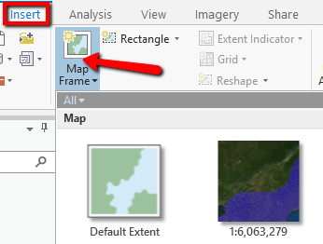
On the Insert tab, click the Map Frame button. This will show the maps you’ve created in your project. Choose one of them to add the layout, and then drag a box on your Layout to add the map frame to the layout. Click and drag the map frame toward the guides, and note that it will “snap” to the guide, aligning itself to the guide.

- Navigation in Layout.
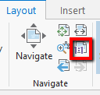
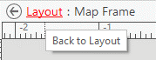
Click Layout and Navigate, and your mouse cursor will change to a hand. This allows you to pan within the layout, by clicking and dragging. You can also zoom in and out within Layout, to see more detail on a certain part of your page. The 1:1 button (boxed in red, on the screenshot above) is useful to preview the actual size of your page, as it will change your layout view to the actual size it will be printed out. Note that your map frame does not change as you navigate around the layout. To zoom in or out of your map, you must activate it. Right click the map frame and choose Activate. Now you can pan and zoom within the map you selected, if you want to change how it looks. Also note that in the upper left of your layout view it says “Layout: Map Frame” to indicate that you’ve activated the map. To return to the Layout, click the underlined Layout (see screenshot at right). Now you’ll be able to navigate within the page layout again.

- Add a Scale Bar to your Layout.
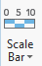
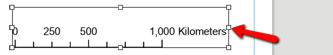
Understanding the scale of geographic data is crucial for the map to be interpretable by a user. All maps should indicate scale, whether by a scale bar, scale text, a coordinate grid or some combination of these three. To add a scale bar to your layout, first click on the map frame for which you want the scale bar. Then click the Insert tab, and the Scale Bar button. Choose a scale bar style and units of Imperial or Metric. Click and drag a box on your layout to add the scale bar. Adjust the width of the scale bar by so it ends in an even, rounded number, for example 1,000 Kilometers instead of 980 Kilometers. Do this by clicking on the scale bar so it is selected, and clicking and dragging the small squares on the perimeter of the scale bar (see red arrow on screenshot at right). The number of divisions shown on the scale bar, font size and type, and many other options on the scale bar can be adjusted by right clicking on it and choosing Properties. This will open the Element pane, that allows for customized formatting of the scale bar. To add scale text, click Insert > Dynamic Text and Scale. Then drag a box on the map, and the scale text will be added. To add a coordinate grid (also called graticules) on the edges of your map, click the map frame to select it, and click Insert Grid. Choose the style of graticules you want, and the grid will be added to the map. Notice you can adjust the properties of the coordinate grid like the interval spacing and units in the Elements pane.

- Add a Legend.
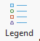
Map legends (also called a “map key”) are important to include on your layout because they explain what the various symbols and colors on the map mean. To add a legend to your layout, click Insert and the Legend button. Drag a box on your map and the legend will be added. Layers that are turned on in the Contents pane will be included in the legend. The legend is linked to the map, so if you change colors or symbols on the map, the changes will be reflected in the legend. The legend is highly customizable. Spacing, font sizes, symbol patch sizes, number of columns and much more can be adjusted on a legend. To access these customizations, select the legend on the layout, and the Legend properties will appear in the Elements pane. If your Elements pane is not open, right click the legend and click Properties to open it. See screenshot below.

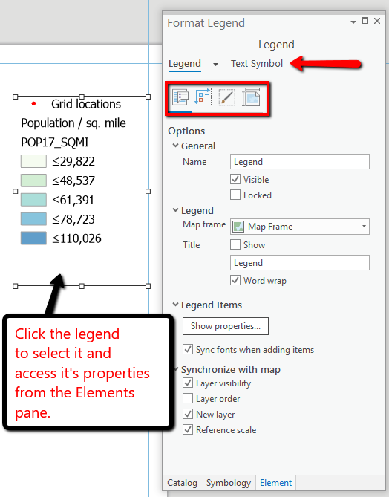

For the legend, different arrangement, display and placement options can be adjusted by choosing different buttons in the Format Legend dialog (see red square on screenshot above). The text size and font can be adjusted by clicking the Text Symbol option (red arrow, screenshot above). Experiment with the different legend formatting options to see how they change the legend.

- Add a North Arrow.
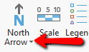
Click Insert and the North Arrow button. If you click the tiny arrow on the bottom of the button (see red arrow on screenshot at right) a list of styles will be displayed. Choose a style, and drag a box on your layout to add the north arrow. The north arrow color and style can be adjusted while it is selected in the Element pane.

- Add a Title and Explanatory Text.
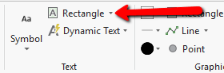
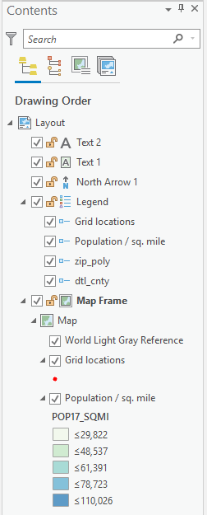
A title is an essential part of any map, and often explanatory text is needed to give the map reader further understanding. On the Insert tab the Text group click the arrow next to where it says Rectangle (see red arrow on screenshot at right). This will give you the option to add text within a box, circle, ellipse, polygon, or on a curved line. Choosing “Text” and then clicking on the map will allow you to add text by itself. Choose Text, click on the map, and the word Text will appear on the map. Click on this, and enter a title for your map. You can change the font style, size, and color for the text using the Format Text options in the Element pane. Choose the text button again, and click on the layout again to add explanatory text.
- Manage layout elements in the Contents pane.
While in Layout view, the Contents pane will show all of the elements on your layout (screenshot at right). Just like map layers, they will draw from the bottom of the list to the top. You can change this order by dragging and dropping individual elements. For example, if you want the map title to be on top of the map, drag it above the map frame in the Contents pane. You can also adjust the map symbology from the Contents pane, just as you would on a map. Locking elements can also be accomplished by clicking the padlock symbol next to the element. This will prevent accidental deletion or movement of that element on the map. Locking a map on your layout will also fix it’s symbology and map extent to what is currently shown. If you want to align multiple elements on the map layout, you can select them by holding the shift key and clicking them on the layout, OR clicking them in the Contents pane. Then, right clicking will give you the option to align, or change the properties for all selected elements.
- Graphics and Pictures.
You may want to insert a photo from the field, or another image onto your map layout. This can be done on the Insert tab in the Graphic group, by clicking Picture (see screenshot below).
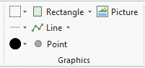
Note that you can also draw different graphics like shapes and lines. You may want to add these to emphasize different items on your layout, or to “connect” different maps, graphics, or pictures with lines or arrows.
- Print / Export your layout.
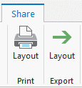
When your layout is completed, it can be printed or exported to an image for insertion into a word document or viewing on the web. Click the Share tab at the top, and choose the Layout Print button to print. Choose a printer, and click Print. To export to an image, click the Layout Export button. When exporting the layout for inclusion in a printed document like a journal or thesis choose JPEG as the type, and make sure the Resolution is set to 300 DPI. If exporting an image for viewing on the web, choose 150 dpi, and type JPEG. You can drag and drop the resulting image into a web browser to see how it will appear on the web. Computer screens have much lower resolution that ink on paper, so high resolution is not needed for images viewed on computer screens.

Additional resources:
This 3 minute video by Esri: https://www.youtube.com/watch?v=NZ9ei4-23MM shows layout creation, adding guides, a primary map and an overview map, legend, scale, and north arrow to a map frame.
This 3 minute video by Esri: https://www.youtube.com/watch?v=i2iI86f6XqU show how to reshape and activate map frames, using Bookmarks, inserting and aligning elements, using the design and format tab.
This 12 minute video: https://www.youtube.com/watch?v=9rukDFkIOIw walks through how to do some more complex layout operations like converting a legend into multiple columns, removing the basemap credit text, adding an inset map, adding a chart, aligning map elements, and adding labels.

